**IMAGE RECOGNITION WITH IBM CLOUD VISUAL**

**RECOGNITION**

Image recognition is the ability of software to identify objects, places, people, writing and action in digital images. Image in IBM cloud can capture an image of a virtual server to quickly replicate its configuration with minimal changes in order process. Image recognition software normally assigns a classification label to each frame of an image or video. Image recognition systems might only need to identify the presence of certain features or patterns within an image or video, without necessarily localizing them.

**INNOVATIVE STEPS:**

1. Setup:

- Install necessary libraries such as OpenCV for image processing and a sentiment analysis library (e.g., NLTK, TextBlob, or VADER).

2. Load Image:

- Use OpenCV to load the image you want to generate a caption for.

3. Preprocess the Image (Optional):

- You can resize, crop, or apply any necessary preprocessing to the image to improve sentiment analysis.

4. Perform Sentiment Analysis:

- Use a sentiment analysis library to analyze the sentiment of the image. This involves extracting text from the image (if any) or using the image content itself.

5. Generate Caption:

- Based on the sentiment analysis results, create a caption that reflects the emotions and mood of the image. You can use conditional statements to map sentiment scores to corresponding captions.

6. Display or Save Caption:

- You can choose to display the generated caption alongside the image or save it to a file.

**IMPLEMENTATION STEPS:**

Step 1: Data Collection: Gather a dataset of images with associated sentiment labels. You can use existing datasets like the AffectNet or create your own by crowdsourcing sentiment annotations.

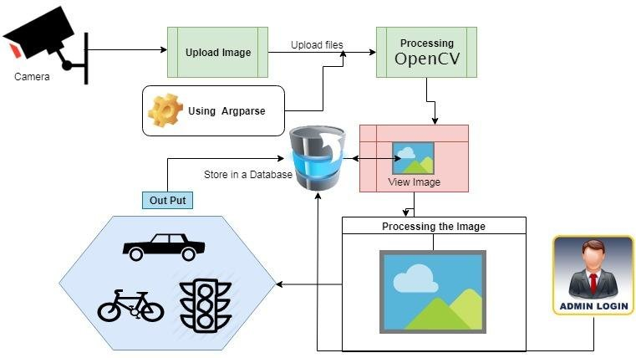

Step 2: Preprocessing: Preprocess the images and convert them into a format suitable for analysis. Extract features using techniques like CNNs (Convolutional Neural Networks) or pre-trained models like VGG, ResNet, or Inception.

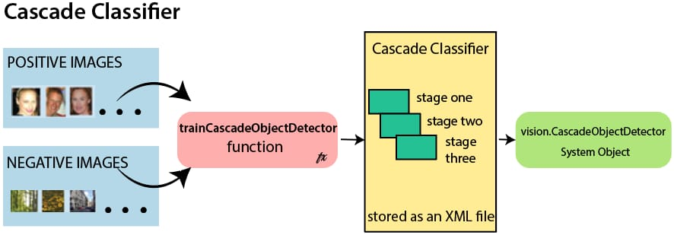

Step 3: Sentiment Analysis: Implement a sentiment analysis model, which could be a deep learning model like an LSTM (Long Short-Term Memory) or a Transformer-based model like BERT. Train this model on the sentiment-labeled dataset to predict emotions or sentiment scores for each image.

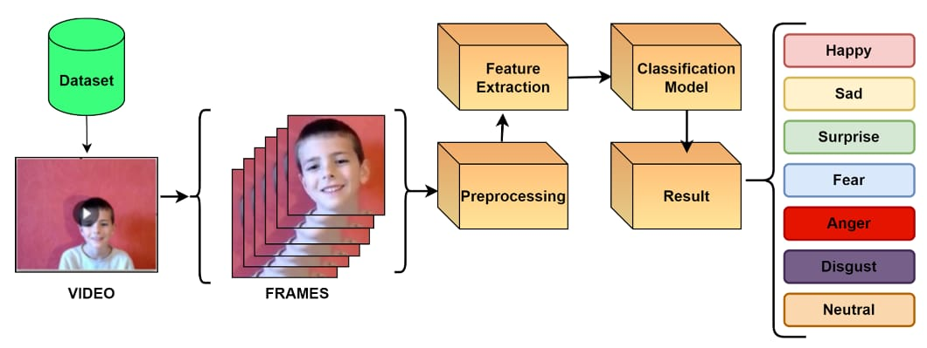

Step 4: Image Captioning Model: Build or use a pre-trained image captioning model. Popular choices include models based on recurrent neural networks (RNNs) or transformer architectures. You can fine-tune a pre-trained model on your specific task.

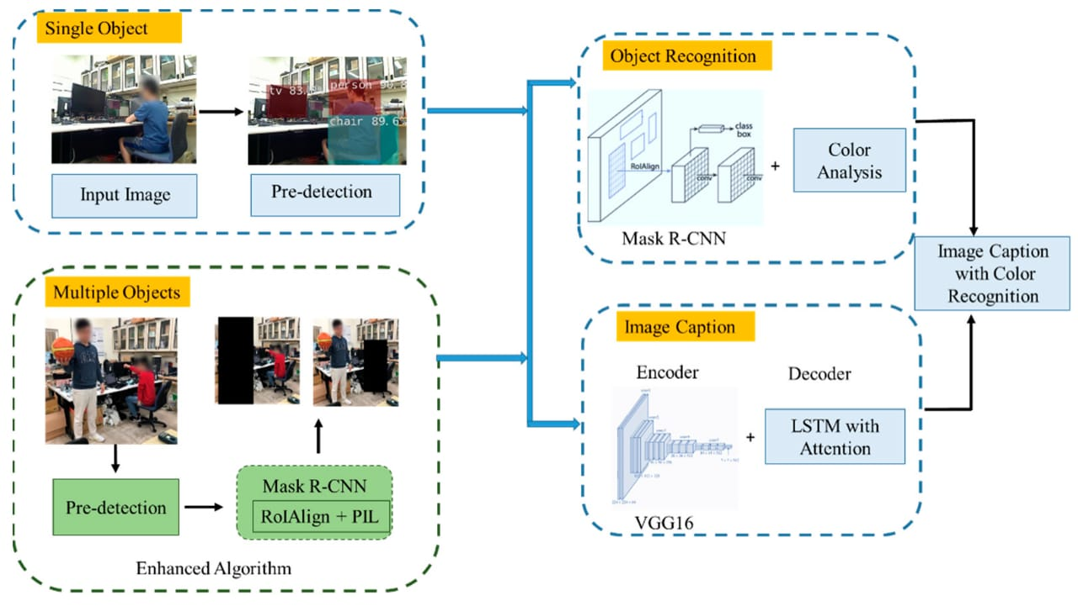

Step 5: Combine Sentiment and Captioning: Modify the image captioning model to incorporate sentiment information. You can concatenate the sentiment scores or embeddings with the image features as an additional input. This guides the model to generate captions that reflect the mood or emotions in the image.

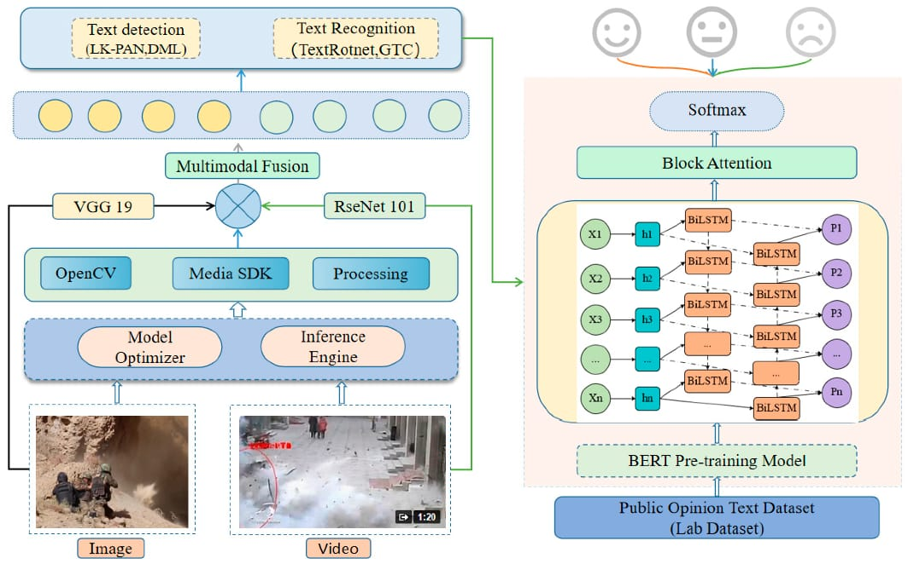

Step 6: Evaluation: Establish evaluation metrics to measure the performance of your model. Metrics like BLEU, METEOR, or ROUGE can be used to evaluate the quality of generated captions. Additionally, you can assess how well the generated captions match the predicted sentiments.

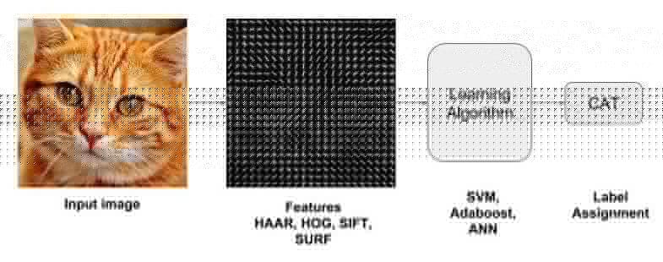

Step 7: Fine-Tuning: Fine-tune your combined model on a validation set to optimize its performance. Experiment with hyperparameters to achieve the desired route.

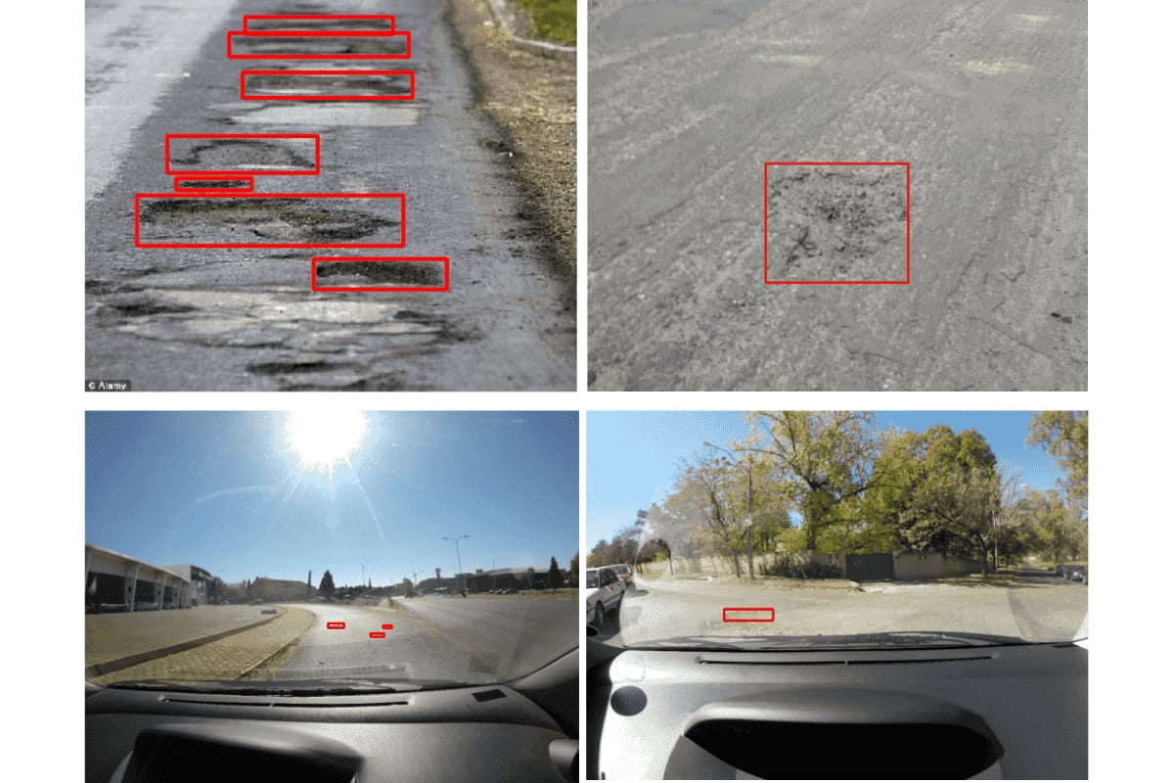

Step 8: Testing and Deployment: Test your model on a separate test dataset to ensure it generalizes well. Once satisfied with the performance, deploy the model in your application or system.



Step 9: Continuous Improvement: Continuously monitor and improve the model's performance by collecting user feedback and retraining it with new data.

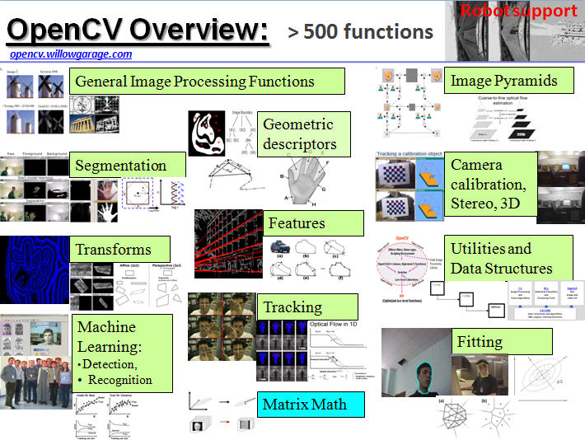

Step 10: User Interface: Design a user-friendly interface that displays the image along with the sentiment-aware caption to enhance the user experience.

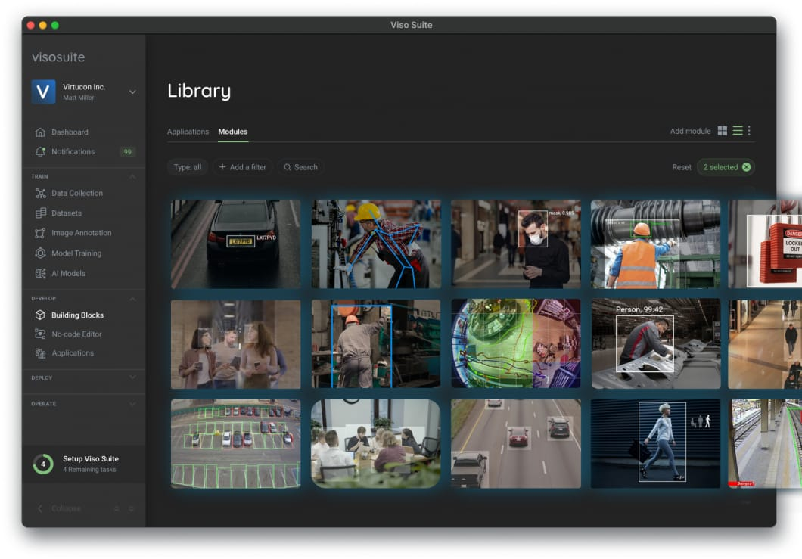

**FLOWCHART:**

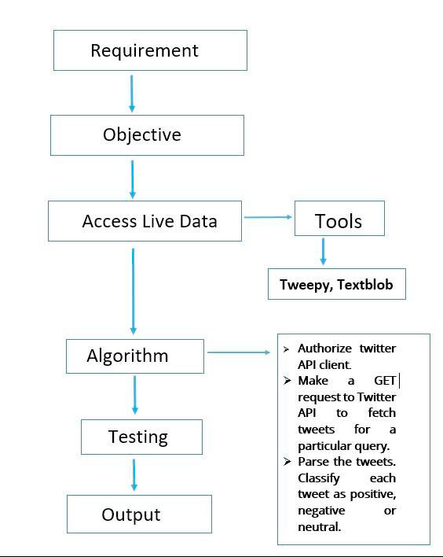

**CONCLUSION:**

We conclude that, incorporating sentiment analysis into image caption generation holds great potential for enhancing the emotional and mood-driven aspects of image descriptions. By leveraging advanced natural language processing techniques, we can create captions that not only describe the visual content but also convey the underlying emotions and mood, making the viewer's experience more immersive and engaging. This approach has the potential to revolutionize how we interact with images, making them not just visually appealing but emotionally resonant as well. As technology continues to advance, integrating sentiment analysis into image captioning systems is a promising direction for enriching our digital storytelling and communication.